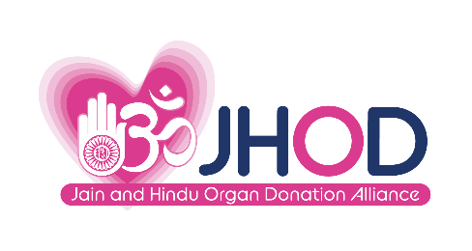
November 2022 : 4 pages
Diwali celebration honours organ donors and winners of children’s art competition
For inquiries, please contact: Prafula Shah, 07789 874 228 or prafulashah.jhod@gmailcom

Young winners of an art competition to promote organ donation and highlight the importance of recycling were announced at a Diwali celebration event organised by the Jain and Hindu Organ Donation Alliance (JHOD) on 5 November 2022 in London.
The event was attended by many community leaders and distinguished guests including the Mayor of Harrow, Cllr Janet Mote, Bob Blackman MP for Harrow East and Cllr Muhammed Butt, Leader of Brent Council, Cllr Krupesh Hirani, Brent & Harrow Member for London Assembly as well as Cllr Shama Tatler and Cllr Krupa Sheth.
JHOD also honoured living donors and donor families from both the Jain and Hindu communities, who shared their touching personal stories including a moving account from Cllr Janet Mote, Mayor of Harrow. She spoke about her wish to donate a kidney to her husband Chris, which sadly didn’t take place due to the pandemic.
Jain and Hindu Organ Donation Alliance has recently become a charity and announced three eminent patrons during the evening: Lord Jitesh Gadhia; Professor Sir Nilesh Samani and singer, song writer and musician Navin Kundra.
76 children participated in the arts competition and the winners were awarded prizes at the event. Overall winner of the competition was Ria from Leicester, aged 8, whose 3D entry won the hearts of the judges. In her statement Ria passionately said: “My inspiration is my grandfather (nana)- he had kidney problems and used to go to hospital 3 times a week for 7 hours and he was always sad and tired. He was donated a kidney and is much happier and his life is much better, he no longer goes to hospital for dialysis”. Ria also mentioned how recycling paper saves trees, plastics are bad and pollute oceans and soil, killing animals who eat plastics and how dumped plastic stays in our oceans for many many years.
Kirit Modi, Chair of JHOD said: “We know that, because of COVID, there are significantly more people waiting for an organ transplant. We are keen and ready to establish partnerships with local authorities, NHSBT, hospitals, community groups and other ethnic minority groups to help address the backlog caused by COVID.”
JHOD is now a well-established charity promoting organ donation among the Hindu and Jain communities in the UK and it was a great pleasure to honour living kidney donors and family members of deceased donors at our Diwali celebrations. It was also heart-warming and impressive to see children engaging in organ donation conversations via artwork highlighting organ donation and recycling.”
“I am delighted to welcome our three patrons Lord Jitesh Gadhia, Prof Sir Nilesh Samani and Navin Kundra, who will offer invaluable support in the development of JHOD and we are looking forward to working with them.”
Lord Jitesh Gadhia, Patron of JHOD, said: “It has been a great pleasure to see JHOD go from strength to strength since its inaugural meeting at the Houses of Parliament in July 2019. I am delighted to be announced as a patron of JHOD. The introduction of an opt-out system has brought new hope to those waiting for an organ transplant, however there is still lots of work to be done. I am proud that JHOD continues to lead the way, providing culturally appropriate and patient friendly information to promote organ donation and transplantation within the South Asian Community. Diwali offers us all a moment to reflect on the noble examples of Lord Rama and Sita, who embodied the noble virtues of sacrifice, service and duty – values which remain more relevant than ever.”
Professor Sir Nilesh Samani, Patron of JHOD, said: “Organ donation can provide a gift of life to someone. There is an urgent need for more organ donors from the Asian community. The mission of JHOD is therefore vital - to raise awareness of organ donation and to provide information and support to families in making the decision to donate. This is a noble cause and I am delighted to serve as a Patron of JHOD”.
Navin Kundra, Patron of JHOD, said: “I am delighted to be a Patron of the Jain and Hindu Organ Donation Alliance to help raise awareness and spread the importance of donating organs and potentially saving lives among the South Asian communities nationally. This cause is very close to my heart and I hope to support the excellent work of JHOD by extending the audience reach and opening important dialogues with families about this cause to encourage more organ donations.”
Prafula Shah, Secretary and Trustee of JHOD said: “Our mission is that no one should die waiting for an organ transplant in our communities. The challenge is huge with those waiting on transplant waiting lists increasing after the pandemic and a range of barriers. But, working closely with our patrons, trustees and community partners, we will continue to encourage conversations about organ donation, building trusted partnerships and vocal campaigns to take the message home.”
Ends
For further information, contact: Prafula Shah, 07789 874 228 prafulashah.jhod@gmail.com

The competition winners announced at the JHOD Diwali celebration were
Overall winner: Riya aged 8
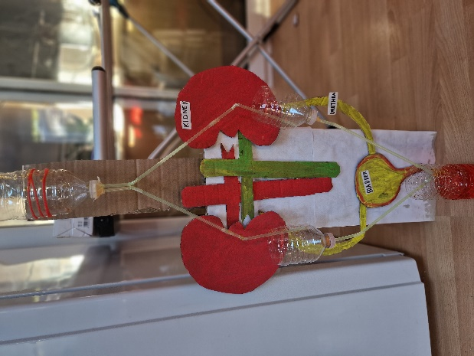
An extract from Ria’s statement:
My inspiration for the competition is my grandfaether (nana). He had kidney problems and used to go to hospital for dialysis 3 times a week for 7 hours each time! He was always tired and sad. He is now better because he was donated a kidney. This means he longer goes to hospital every week and is much happier and living a better life than before. I have designed a kidney model which shows how the kidney works.
Plastics are bad for the oceans and soil, they kill animals who eat them and dumped plastic stays in our oceans for many many year
Aarna, aged 9 : Category 5 to 10 years – Runner Up
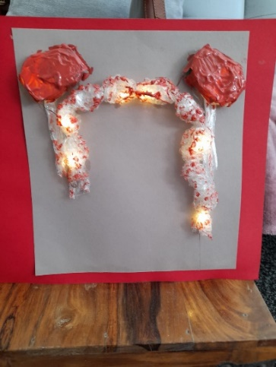
Extract from Aarna’s statement:
One Pair: One to Keep & One to Share Give the gift of life - share what you don’t need. Half & Half— Alive Together Share Your Spare Raise awareness for kidney care… so one day we don’t have to share. A very close friend of mine, who does tuitions with me, was diagnosed with an illness which couldn't be cured without an organ donation. She is amidst us just because one of you have been kind enough to sign up and donate. That has inspired me that how important it is to educate people on organ donations. It does save a life. It does make you immortal, it does bring hope in a family who needs it for their loved ones. I have created kidneys and how it has proven that someone who donates 1 kidney can still live on another kidney. I have used bottle caps, bubble wrap and a light that came out of the broken glass decoration bottle. The lights impact's the ray of hope in the darkness of the person who needs one.

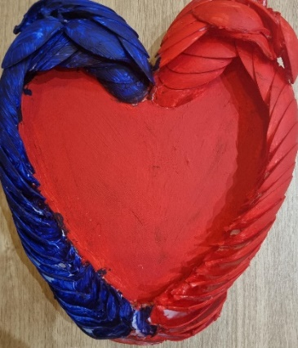
Zara, aged 8: Category 5 to 10 years – Winner
An extract from Zara’s statement:
I chose to work on a heart because it is vital and helps to pump blood around our body. It also allows us to feel emotions like love, which is very important.
I think organ donation is important as it can help someone in need of an organ live with the help of organ donation from someone who no longer needs their organs.
It is best to encourage and educate people to donate their organs

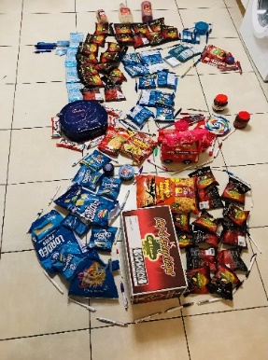
Karuna, aged 11: Category 11 to 18 years – Runner Up
An extrat from Karuna’s statement:
I chose a heart for my mural because it is a symbol of love and giving. We should to all we can to help others and organ donation helps to save lives. I have used sweet wrappers and other packaging in my mural. Sometime we waste things but they can be used again,

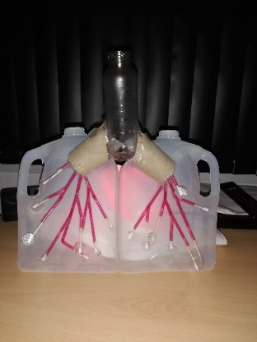
Shivam, aged 12 : Category 11 to 18 years – Winner
An extrat from Shivam’s statement:
My grandmother, who I never had a change to meet, left us in 2002, aged 55. She was waiting for a lung and heart transplant but being a small Asian lady meant it was difficult to get a donor from the South Asian community. My grandmother may have gotten to live longer and better quality of life if a donor was found. So, encourage people to share of success and failure transplant stories from our communities. I believe reduce, reuse and recycling of plastics is key for humans and nature and plastics are ruining our historical relationship with nature.
Category Class/Family – Runner Up : Jalaram Balk Vikas, Leicester
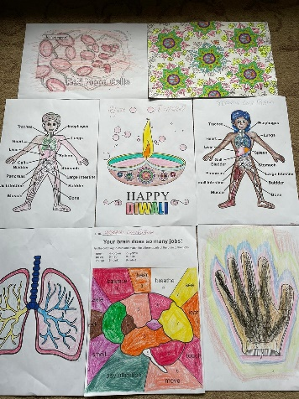
An extract from their statement:
Our school has been learning about organ donation and the issues associated with our communities and organ donation. An organ donation workshop was held with talks and a Q&A and we have incorporated this very valuable information on organ donation into our Diwali arts workshop.

Category Class/Family – Joint Winners: Shrimad Rajchandra Divinetouch : Friday class and Sunday class
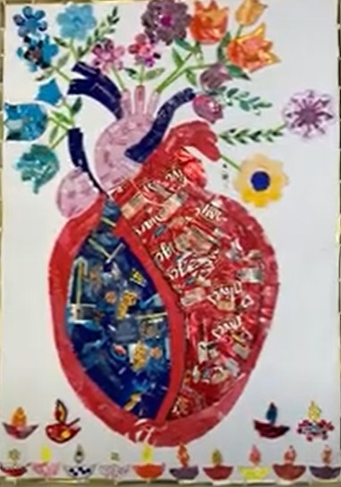
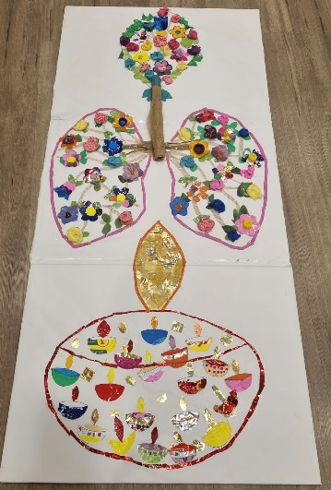
Extract from Friday class statement:

We present our collage of lungs looking like trees and flowers made using recycled materials. Trees are the ‘lungs of the earth’ and produce the oxygen we breathe, giving us the gift of life. Helping another to breathe by donating our lungs, and other organs, is a selfless form of daan.
It is essential to reduce, reuse, recycle as much as we can to stop polluting the planet, wasting resources and harming sea creatures. We can also make something useful like this poster to bring awareness of organ donation and the environment and talk to our friends.

An extract from the Sunday class statement:
We submit a collage of the Heart organ holding beautiful flowers that show ‘living’, just
as a heart keeps someone alive, the flowers are also alive! The heart and flowers are
also both symbols of LOVE!
This art piece was created by children cutting waste into smaller pieces and collaging
them into a heart holding flowers.
It is important to recycle waste as it is with organs as both can save lives - like sea
creatures die from eating plastic waste this can be prevented by recycling.
Organ donation information can reach more people by making posters, talks in schools
and more competitions like this one!

